Project Design Phase-II
Data Flow Diagram & User Stories
Date | 8 March 2026
Team ID
Project Name | Avi-Luxe E-commerce Application
Maximum Marks | 4 Marks

Data Flow Diagrams
A Data Flow Diagram (DFD) is a traditional visual representation of the information flows within a system. It shows how data enters and leaves the system, what changes the information, and where data is stored. The diagrams below follow standard DFD notation: rectangles represent external entities, numbered circles represent processes, and open-sided rectangles represent data stores.

DFD Level 0 — Context Diagram
The Level 0 DFD (Context Diagram) presents Avi-Luxe as a single central process interacting with three external entities: Customer (Web/Mobile User), Administrator, and Payment Gateway. All data flows between the system and the outside world are shown at the highest level of abstraction.

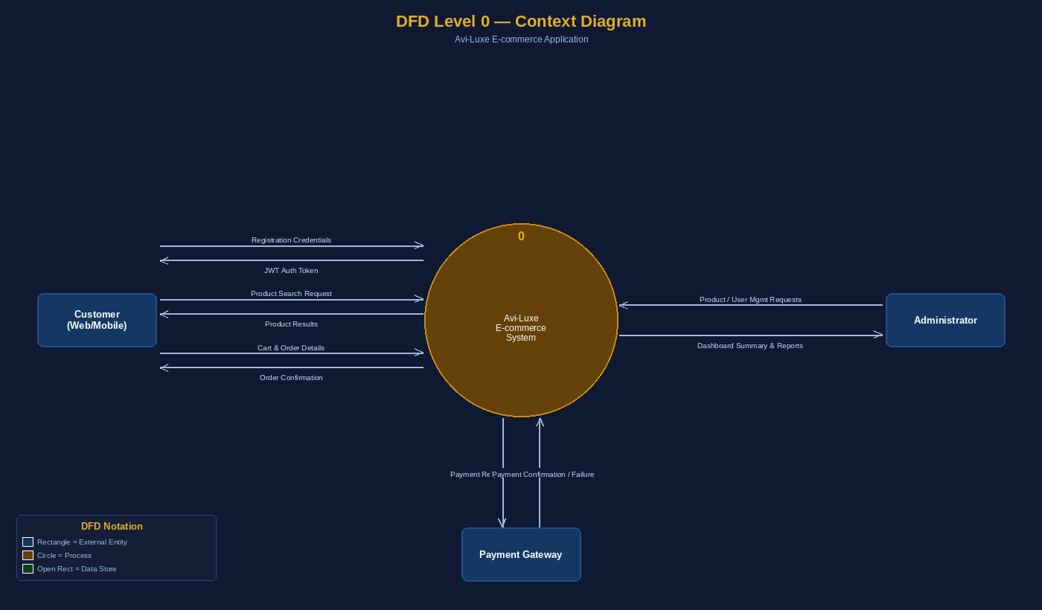

Data Flow Descriptions — Level 0
• Customer → System: Registration credentials (name, email, mobile, address, password) → Auth Process → User DB
• System → Customer: JWT Auth Token issued on successful registration or login → Dashboard access granted
• Customer → System: Product search requests (keyword, category, gender, price range) → Product Catalog → Product DB
• System → Customer: Filtered product listings and full product detail returned to browser
• Customer → System: Cart actions (add/update/remove) and order placement with shipping details → Order Processing → Orders DB
• System → Customer: Order confirmation with order ID, items, total amount, and Pending status
• System ↔ Payment Gateway: Payment request sent; confirmation/failure response received and stored
• Administrator → System: Product CRUD, order status updates, user management → Admin Panel → Product DB / Orders DB / User DB
• System → Administrator: Dashboard summary — user count, product count, revenue, order totals

DFD Level 1 — Sub-Process Decomposition
Level 1 decomposes the Avi-Luxe system into 6 numbered sub-processes, each interacting with specific data stores. External entities (Customer and Administrator) are the same as in Level 0.

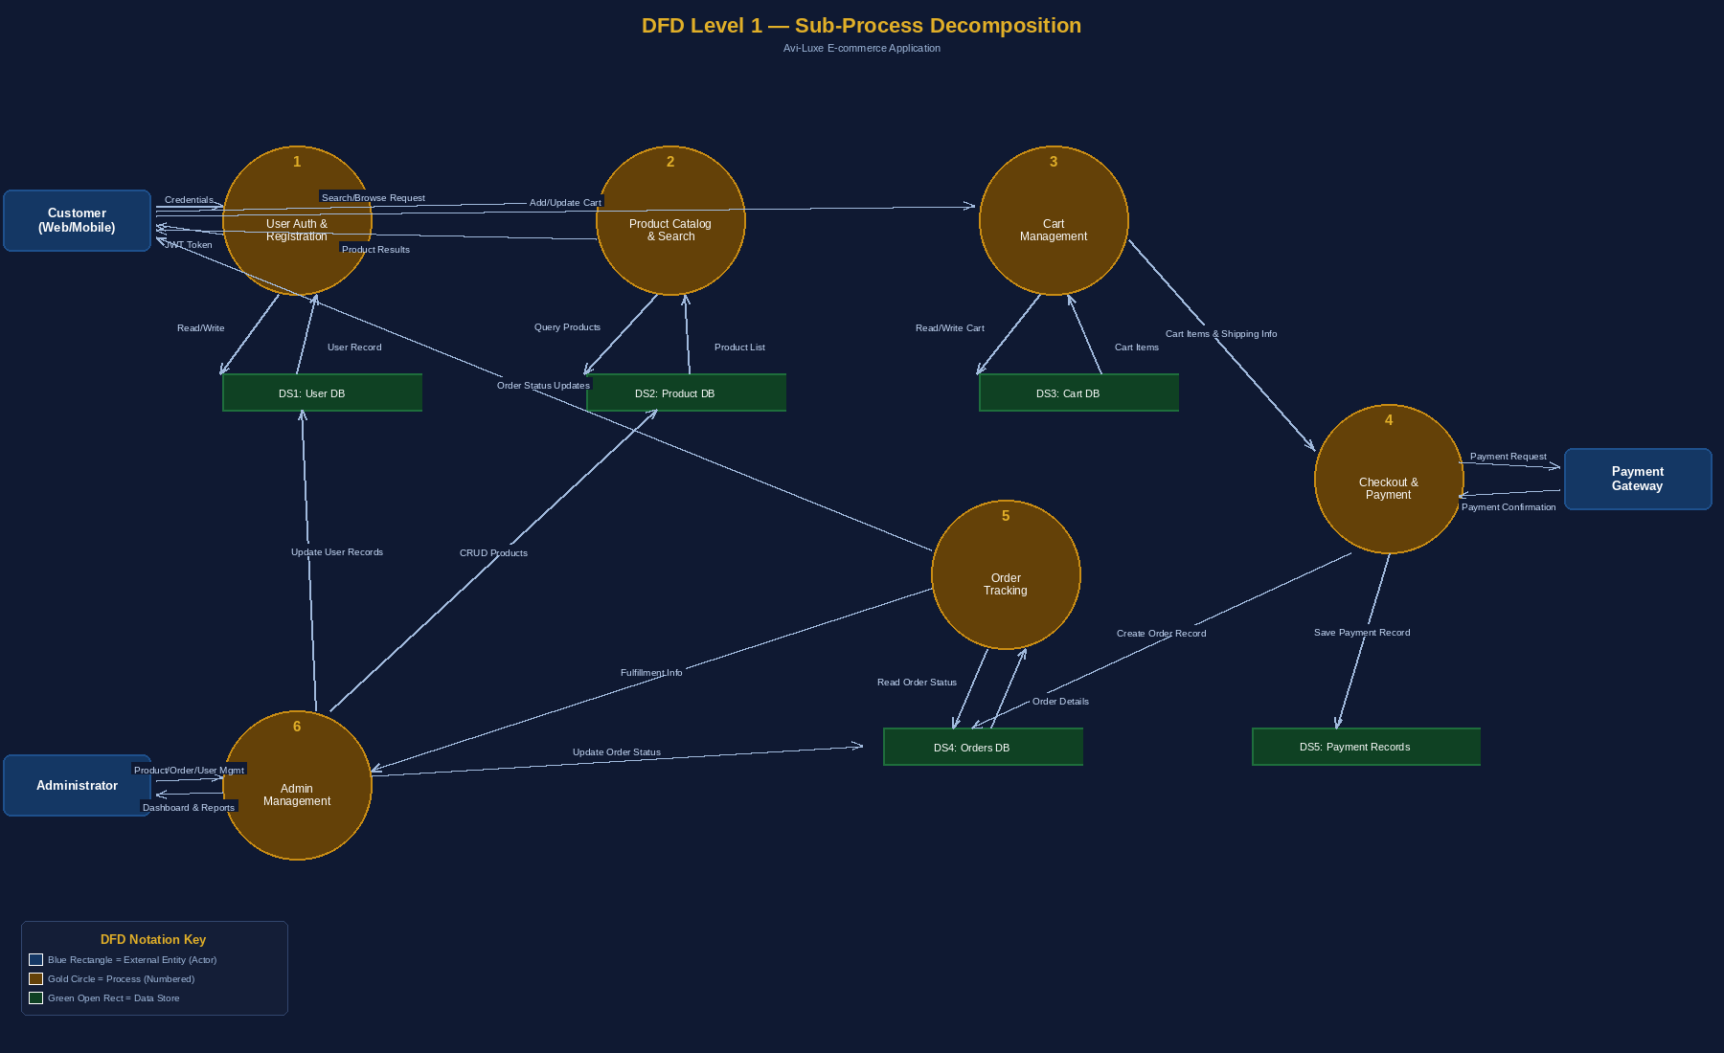

Process Descriptions — Level 1
• Process 1 — User Auth & Registration: Accepts registration/login credentials, validates against User DB, hashes password with bcryptjs, issues JWT, blocks inactive accounts.
• Process 2 — Product Catalog & Search: Fetches active products from Product DB with server-side filtering (category, gender, price range) and regex text search on title and description.
• Process 3 — Cart Management: Reads/writes Cart DB per authenticated user. Handles add (increments qty for duplicates), update (qty/size), remove item, and clear cart.
• Process 4 — Checkout & Payment: Validates shipping address fields, calculates prices server-side (subtotal, discount, total), creates Order record in Orders DB, saves payment method reference.
• Process 5 — Order Tracking: Reads order status from Orders DB; surfaces status timeline to Customer; Admin updates flow through this process.
• Process 6 — Admin Management: Full CRUD on Product DB, status updates to Orders DB, read/update/deactivate records in User DB, aggregated revenue calculations for dashboard.

Data Stores
The following table describes each data store in the Avi-Luxe system, based on the actual MongoDB Mongoose models:

Data Store | Description | Key Fields
User DB | Stores registered user accounts, passwords (hashed), roles, and address details | _id, name, email, password_hash, mobile, address, role, isActive, createdAt
Product DB | Stores all product listings, categories, inventory, brands, and images | _id, title, brand, description, mainImg, carousel, category, gender, sizes, price, discount, rating, ratingsCount, stock, isActive
Cart DB | Stores active shopping cart items per user; persists across sessions | _id, user_id, items[{product, title, mainImg, size, quantity, price, discount}]
Orders DB | Records all placed orders, shipping addresses, payment method and fulfillment status | _id, user_id, items[], shippingAddress, paymentMethod, prices{subtotal,discount,total}, status, orderDate, deliveryDate
Payment Records | Stores payment transaction details and gateway response data per order | Captured within Order document: paymentMethod (cod/card/upi/netbanking), prices.total, status
Admin Settings DB | Stores per-admin configuration: homepage banner items and product category lists | _id, adminUser_id, banner[{title, imageUrl, link}], categories[]

User Stories
The following table lists all user stories for the Avi-Luxe E-commerce Application, organized by user type and functional epic. All stories are based on the actual implemented API routes, controllers, and client-side pages in the codebase.

User Type | Functional Requirement (Epic) | Story No. | User Story / Task | Acceptance Criteria | Priority | Release
Customer (Mobile/Web) | Registration | USN-1 | As a user, I can register by entering my Full Name, Email, Mobile, Address and Password (min 6 chars). | Can access account and dashboard | High | Sprint-1
 |  | USN-2 | As a user, I receive a JWT token immediately upon successful registration and am logged in. | Redirected to home/dashboard with active session | High | Sprint-1
 |  | USN-3 | As a user, existing email registration is rejected with a clear error (HTTP 409 Conflict). | Error message shown: 'User already exists' | High | Sprint-1
 |  | USN-4 | As a user, I can register via Google OAuth (planned). | Can access dashboard with Google Login | Medium | Sprint-2
 | Login | USN-5 | As a user, I can log in with Email and Password; a JWT is issued on success. | User redirected to dashboard | High | Sprint-1
 |  | USN-6 | As a user, I am blocked from logging in if my account is inactive (isActive: false). | Error: 'User account is inactive' | High | Sprint-1
 | Product Catalog | USN-7 | As a user, I can browse all active products in the shop with search, category and gender filters. | 26+ products shown; filters update results in real-time (350ms debounce) | High | Sprint-1
 |  | USN-8 | As a user, I can search products by name or description keyword. | Matching products returned using case-insensitive regex | High | Sprint-1
 |  | USN-9 | As a user, I can filter products by price range (minPrice / maxPrice). | Filtered results update dynamically | Medium | Sprint-2
 |  | USN-10 | As a user, I can view a product detail page with full info: images, brand, category, sizes, price, discount, rating. | Product detail page loads with all fields | High | Sprint-1
 | Cart | USN-11 | As a user, I can add a product to my cart (with size selection). If same product+size exists, quantity is incremented. | Cart updates with product and quantity; badge count updated in navbar | High | Sprint-1
 |  | USN-12 | As a user, I can update quantity or size of a cart item. | Cart reflects changes immediately | High | Sprint-1
 |  | USN-13 | As a user, I can remove a single item from my cart. | Item removed; cart total recalculated | High | Sprint-1
 |  | USN-14 | As a user, I can view a cart summary showing subtotal, discount (per-item %), and total. | Correct totals displayed before checkout | High | Sprint-1
 | Checkout | USN-15 | As a user, I can enter shipping details (Full Name, Mobile, Address, Pincode) — pre-filled from my profile. | Shipping fields auto-filled from user.address | High | Sprint-1
 |  | USN-16 | As a user, I can select payment method (Cash on Delivery; Card/UPI/NetBanking supported in model). | Order created with selected payment method | High | Sprint-1
 |  | USN-17 | As a user, I receive an order confirmation toast notification immediately after placing an order. | 'Order confirmed' toast shown; redirected to Orders page | High | Sprint-1
 | Orders | USN-18 | As a user, I can view my complete order history sorted by newest first, including all items, sizes, quantities, and totals. | All orders listed with correct status badge | High | Sprint-2
 |  | USN-19 | As a user, I can see the current status of each order (Pending / Confirmed / Shipped / Delivered / Cancelled). | Status badge displayed per order | Medium | Sprint-2
 | Profile | USN-20 | As a user, I can view my profile: name, email, mobile, address, role and active cart count. | Profile page loads with correct user data | Medium | Sprint-2
 |  | USN-21 | As a user, I can access Settings, Order History and Cart overview from my profile sidebar. | Navigation links work correctly | Medium | Sprint-2
 | Settings | USN-22 | As a user, I can toggle preferences: Order update alerts, Marketing emails, Concierge mode, Dark luxury theme. | Settings saved and persist in session | Low | Sprint-2
Customer Care Executive | Support | USN-23 | As a customer care executive, I can view and respond to customer queries and complaints. | Responses logged against query | High | Sprint-2
 |  | USN-24 | As a customer care executive, I can process refund or return requests. | Refund initiated and order status updated | High | Sprint-2
Administrator | Product Management | USN-25 | As an admin, I can create a new product with all fields (title, brand, description, images, category, gender, sizes, price, discount, stock). | Product appears immediately in catalog | High | Sprint-1
 |  | USN-26 | As an admin, I can update any product field including toggling isActive (soft-delete). | Changes reflected instantly; inactive products hidden from shop | High | Sprint-1
 |  | USN-27 | As an admin, I can soft-delete a product (sets isActive: false) — order history is preserved. | Product removed from shop; past orders unaffected | High | Sprint-1
 | Order Management | USN-28 | As an admin, I can view all orders with customer name, email, mobile, items and totals. | All orders listed with user details populated | High | Sprint-1
 |  | USN-29 | As an admin, I can update order status (pending → confirmed → shipped → delivered → cancelled) with optional delivery date. | Order status updated; deliveryDate auto-set for 'delivered' | High | Sprint-1
 | User Management | USN-30 | As an admin, I can view, edit and soft-disable customer accounts (isActive: false). | Account status changes take effect immediately | Medium | Sprint-2
 |  | USN-31 | As an admin, I can promote any user to admin role via /api/admin/promote. | User role updated; Admin settings document created | Medium | Sprint-2
 | Analytics & Dashboard | USN-32 | As an admin, I can view a summary: total users, active products, total orders, total revenue (confirmed/shipped/delivered orders). | Real-time aggregated data via /api/admin/summary | Medium | Sprint-3
 |  | USN-33 | As an admin, I can manage homepage banner items and product category lists via /api/admin/settings. | Settings saved and applied to storefront | Medium | Sprint-3

Notes
• Technology Stack: React 19 + Vite 7 (Client) · Node.js/Express 5 (Server) · MongoDB + Mongoose (Database) · JWT + bcryptjs (Auth) · GSAP + Three.js (@react-three/fiber)
• Repository: https://github.com/AVK103/Avi-Luxe__E-commerce-Application
• Sprint-1: Core auth, product catalog, cart, checkout, admin product & order management
• Sprint-2: Orders page, profile, settings, customer care support, admin user management
• Sprint-3: Analytics dashboard, admin settings UI, future Google OAuth integration

